Bash Scripting task:  
====================  
1) Create on Bash script to check if a directory is available or not.

2) Create a bash script which will create multiple files.

3) Create a bash script to take backup of a directory.

4) Create a bash script to install nginx in ec2 server.

5) Create a bash script to install ApacheTomcat in ec2 server.

6) Create a bash script to check list if nginx service is running or not,if not running  
   then script should start the service.

7) Create a bash script for calculator.

8) Create a bash script to check if directory is avaialble or not,if not then create a directory.

9) Create bash script to delete last 3 lines for a file.

10) Execute all the scripts which are available from document

"Script_bash_example.pdf"Note:  
1) All the Scripts needs to be executed on Amazon Linux Ec2.  
2) Please push the scripts in your github repository.  
3) Share the github account url once done for evaluation.

1) Create on Bash script to check if a directory is available or not.

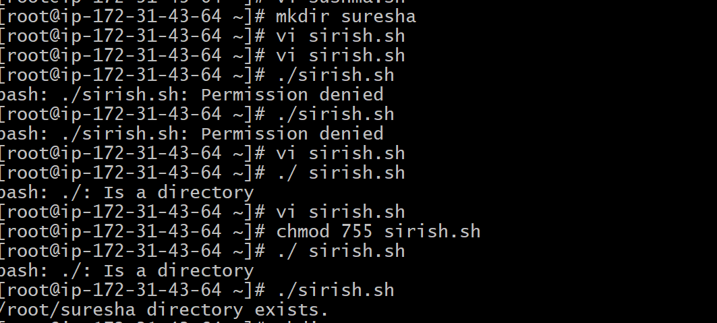

2) Create a bash script which will create multiple files.

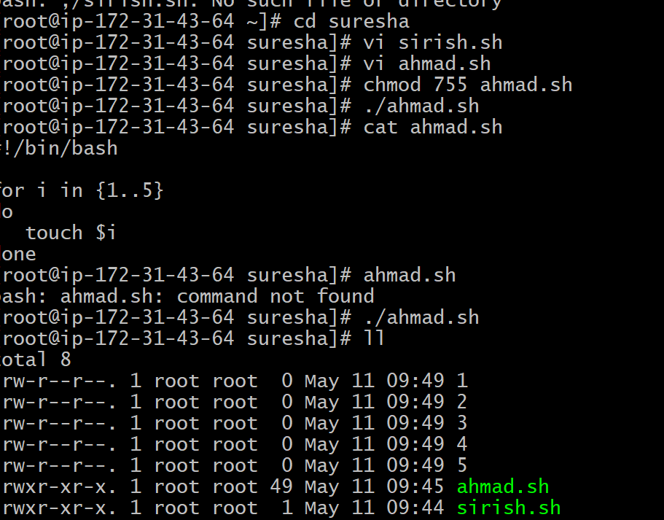

3] Create a bash script for calculator.

